Content Based Video Retrieval
CSE 509 Digital Video Processing, Fall-2015

Jenil Jain
Arizona State University
jpjain@asu.edu
Jayaram Theegala
Arizona State University
jtheegala@asu.edu

Abstract—With the advancements in search engines, available bandwidth as well as computation power, the demand for content based retrieval has increased.
Index Terms—Content-based video retrieval; motion estimation; low level feature extraction.

Introduction (Heading 1)
All manuscripts must be in English. These guidelines include complete descriptions of the fonts, spacing, and related information for producing your proceedings manuscripts. Please follow them and if you have any questions, direct them to the production editor in charge of your proceedings (see author-kit message for contact info).
This template provides authors with most of the formatting specifications needed for preparing electronic versions of their papers. All standard paper components have been specified for three reasons: (1) ease of use when formatting individual papers, (2) automatic compliance to electronic requirements that facilitate the concurrent or later production of electronic products, and (3) conformity of style throughout a conference proceedings. Margins, column widths, line spacing, and type styles are built-in; examples of the type styles are provided throughout this document and are identified in italic type, within parentheses, following the example. PLEASE DO NOT RE-ADJUST THESE MARGINS. Some components, such as multi-leveled equations, graphics, and tables are not prescribed, although the various table text styles are provided. The formatter will need to create these components, incorporating the applicable criteria that follow.

Type Style and Fonts
Wherever Times is specified, Times Roman or Times New Roman may be used. If neither is available on your word processor, please use the font closest in appearance to Times. Avoid using bit-mapped fonts. True Type 1 or Open Type fonts are required. Please embed all fonts, in particular symbol fonts, as well, for math, etc.

proposed framework
The low level feature we used for our implementation was motion vectors. Detecting motion along a particular region of the video can give many details about the content. Motion can be estimated using many algorithms. The limitations on this algorithm is the computation time and power. For calculating pixel by pixel motion vector of two 480 x 640 frames using Lucas-Kanade algorithm took us 6 secs. So for a 5 minute video with framerate 30, we have 9000 frames and it will take 54000 sec, i.e. 15 hours. Even saving the motion vectors in mat files will occupy GBs of memory. MATLAB is not capable of handling such large files. So the motion vectors were calculated for the consecutive frames at an interval of 5. This reduced the overall time as well as space. As Lucas-Kanade is so slow, a better and fast motion estimation algorithm developed by Ce Liu is used. It still takes 1 sec for a motion vector, but comparatively it’s fast.

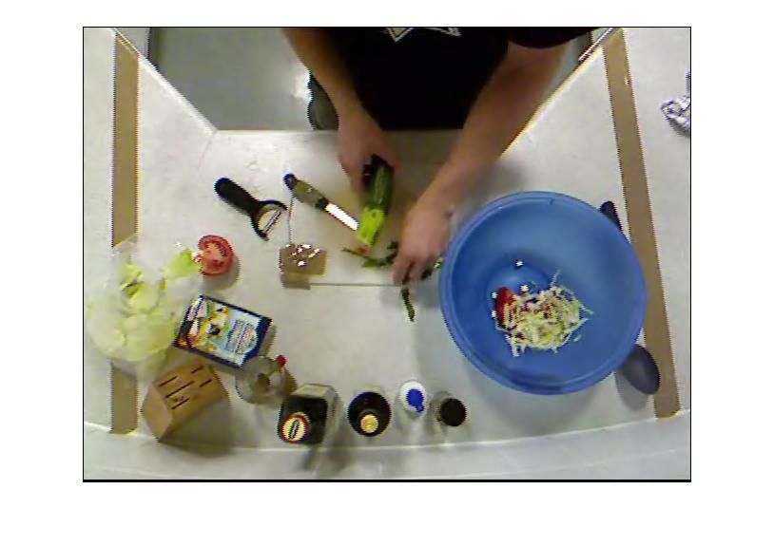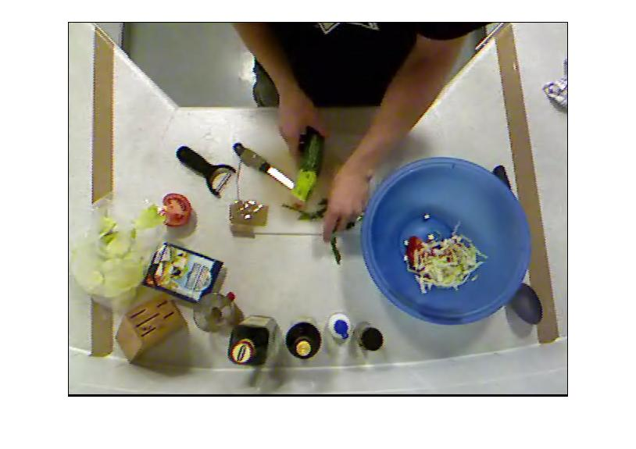
(a) (b)
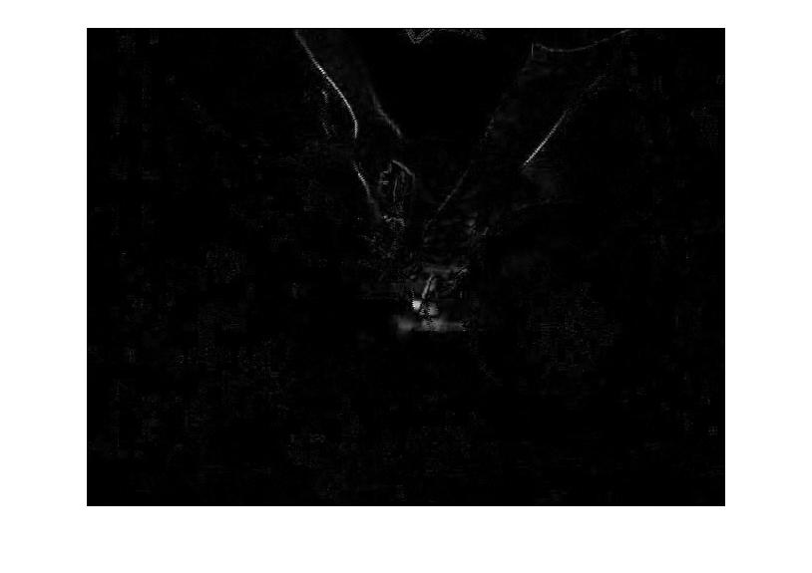
(c) (d)
Fig 1.a frame 1, 1.b frame 2. 1.c difference between them, 1.d motion segmentation along the difference.

The basic assumption is that in an input video, there will be only one activity which we need to identify. Thus motion for that activity will be along some particular region. Segmenting the image based on motion vector using thresholding technique will give us clear picture of what kind of activity is done in which region. For example in the 50 salad dataset, cutting of ingredients is done at the center while mixing is done at the right side for most of the videos. Thus for cutting motion vector will be along the center of the image and for mixing the ingredients, motion vector will be along center as well as right. Similarly preparing the dressing will have motion along bottom as well as center. Thus different activities will have different regions of motion vector. Since it is just low level feature extraction, we cannot differentiate cutting of tomato and cutting of cucumber.
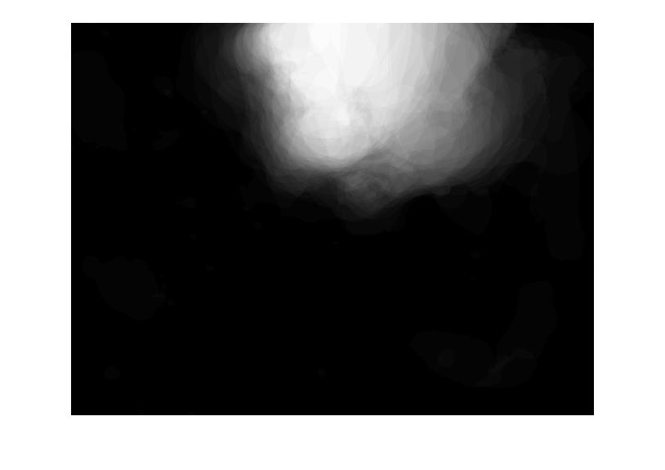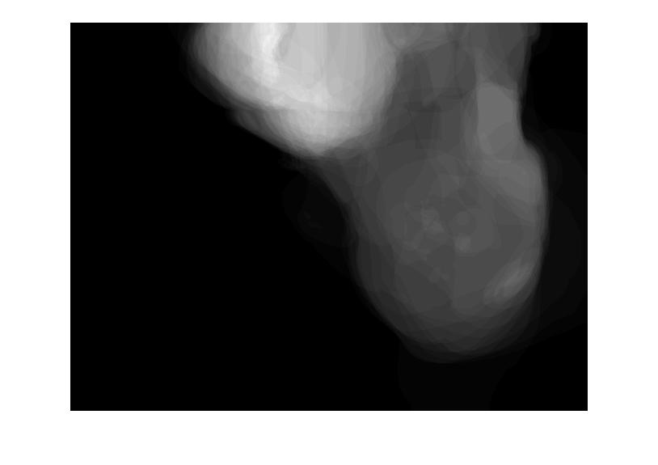
(a) (b)
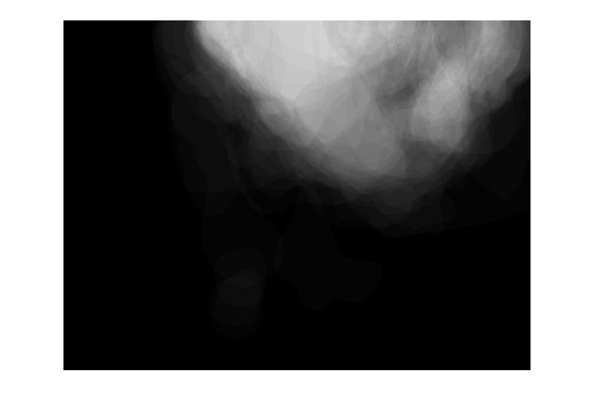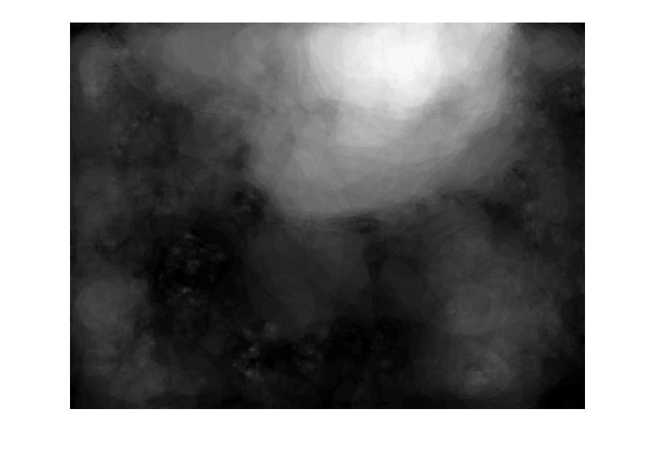
(c) (d)
Fig 2.a Averaged motion vector for a cutting clip, 2.b averaged motion vector for a mixing ingredients clip, 2.c average motion vector for preparing a dressing, 2.d average motion vector for some random activity. For cutting motion vectors are concentrated mainly at the center. For mixing it is concentrated along center as well as right side and for dressing you can see some motion along down side.

Implementation
After extracting the motion vectors and segmenting the image, we classified the frames of the videos in the dataset based on the motion. The classification method we used was k-means clustering. k-means clustering aims to partition n observation into k clusters in which each observation belongs to the clusters with the nearest mean.
k-means in MATLAB take a matrix of n x p where n is the number of observations and p is the number of variables. So in our case n is the number of motion segmented frames and p is the number of pixels in the frame. Since we just need to know in which region the motion has occurred, we divide the whole frame into W x W grid. A grid represent the average value of the pixels in it. So if the motion occurred in that region the average value of the region will be higher than the region with no motion. Hence comparing the regions, we can deduce which activity has occurred. We choose value of W to be 80. Dividing the image into grid also reduce the variable for the k-means.

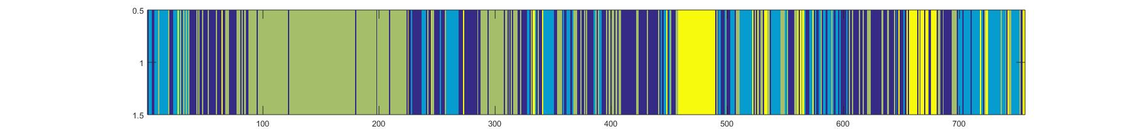

Fig 3 a video clustered using k-means. Region with green uniform area is the cutting of vegetables, region with yellow is the dressing preparation, region with blue region is the mixing ingredients and purple are the one with random activity. There are blue stripes between regions of yellow and green, that is because of adding the ingredients into the bowl.

After clustering the frames in the video, we need to separate the video into sequences of similar k-mean ID. The region with uniform color represents a single activity. Splitting the video into sequences is a onetime process and we can save this information for future iterations. Hence we don’t have to repeat this procedure every time a video is added as input. Comparing this sequences with the input video can show how similar they are. For similarity measure we can use either Euclidean distance or the cosine distance. Rankings can be assigned to these clips based on any of the above measurements.
For ranking the clips we used a simple data structure to store all the clip’s information in ascending order of their respective Euclidean or cosine distance from the input clip.

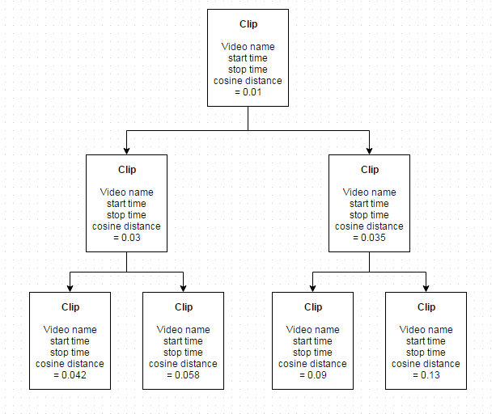
Fig 4. A MinHeap storing all the clips information based on their respective Euclidean or cosine distance from the input clip.

Abbreviations and Acronyms (Heading 2)
Define abbreviations and acronyms the first time they are used in the text, even after they have been defined in the abstract. Abbreviations such as IEEE and SI do not have to be defined. Do not use abbreviations in the title or heads unless they are unavoidable.

Units
- Use either SI or CGS as primary units. (SI units are encouraged.) English units may be used as secondary units (in parentheses). An exception would be the use of English units as identifiers in trade, such as “3.5-inch disk drive”.
- Avoid combining SI and CGS units, such as current in amperes and magnetic field in oersteds. This often leads to confusion because equations do not balance dimensionally. If you must use mixed units, clearly state the units for each quantity that you use in an equation.
- Do not mix complete spellings and abbreviations of units: “Wb/m²” or “webers per square meter”, not “webers/m²”. Spell out units when they appear in text: “. . . a few henries”, not “. . . a few H”.
- Use a zero before decimal points: “0.25”, not “.25”. Use “cm³”, not “cc”. (bullet list)

Equations
The equations are an exception to the prescribed specifications of this template. You will need to determine whether or not your equation should be typed using either the Times New Roman or the Symbol font (please no other font). To create multileveled equations, it may be necessary to treat the equation as a graphic and insert it into the text after your paper is styled.
Number equations consecutively. Equation numbers, within parentheses, are to position flush right, as in Eq. 1, using a right tab stop. To make your equations more compact, you may use the solidus ( / ), the exp function, or appropriate exponents. Italicize Roman symbols for quantities and variables, but not Greek symbols. Use a long dash rather than a hyphen for a minus sign. Punctuate equations with commas or periods when they are part of a sentence, as in
       
Note that the equation is centered using a center tab stop. Be sure that the symbols in your equation have been defined before or immediately following the equation. Use “Eq. 1” or “Equation 1”, not “(1)”, especially at the beginning of a sentence: “Equation 1 is . . .”

Some Common Mistakes
- The word “data” is plural, not singular.
- The subscript for the permeability of vacuum μ₀, and other common scientific constants, is zero with subscript formatting, not a lowercase letter “o”.
- In American English, commas, semi-/colons, periods, question and exclamation marks are located within quotation marks only when a complete thought or name is cited, such as a title or full quotation. When quotation marks are used, instead of a bold or italic typeface, to highlight a word or phrase, punctuation should appear outside of the quotation marks. A parenthetical phrase or statement at the end of a sentence is punctuated outside of the closing parenthesis (like this). (A parenthetical sentence is punctuated within the parentheses.)
- A graph within a graph is an “inset”, not an “insert”. The word alternatively is preferred to the word “alternately” (unless you really mean something that alternates).
- Do not use the word “essentially” to mean “approximately” or “effectively”.
- In your paper title, if the words “that uses” can accurately replace the word “using”, capitalize the “u”; if not, keep using lower-cased.
- Be aware of the different meanings of the homophones “affect” and “effect”, “complement” and “compliment”, “discreet” and “discrete”, “principal” and “principle”.
- Do not confuse “imply” and “infer”.
- The prefix “non” is not a word; it should be joined to the word it modifies, usually without a hyphen.
- There is no period after the “et” in the Latin abbreviation “et al.”.
- The abbreviation “i.e.” means “that is”, and the abbreviation “e.g.” means “for example”.
An excellent style manual for science writers is given by Young [7].

Using the Template
After the text edit has been completed, the paper is ready for the template. Duplicate the template file by using the Save As command, and use the naming convention prescribed by your conference for the name of your paper. In this newly created file, highlight all of the contents and import your prepared text file. You are now ready to style your paper; use the scroll down window on the left of the MS Word Formatting toolbar.

Authors and Affiliations
The template is designed so that author affiliations are not repeated each time for multiple authors of the same affiliation. Please keep your affiliations as succinct as possible (for example, do not differentiate among departments of the same organization). This template was designed for two affiliations.

For Author/s of Only One Affiliation (Heading 3): To change the default, adjust the template as follows.

Selection (Heading 4): Highlight all author and affiliation lines.

Change Number of Columns: Select Format >
Columns >Presets > One Column.

Deletion: Delete the author and affiliation lines for the second affiliation.

For Authors of More than Two Affiliations: To change the default, adjust the template as follows.

Selection: Highlight all author and affiliation lines.

Change Number of Columns: Select Format >
Columns > Presets > One Column.

Highlight Author and Affiliation Lines of Affiliation 1 and Copy this Selection.

Formatting: Insert one hard return immediately after the last character of the last affiliation line. Then paste down the copy of affiliation 1. Repeat as necessary for each additional affiliation.

Reassign Number of Columns: Place your cursor to the right of the last character of the last affiliation line of an even numbered affiliation (e.g., if there are five affiliations, place your cursor at end of fourth affiliation). Drag the cursor up to highlight all of the above author and affiliation lines. Go to Format > Columns and select “2 Columns”. If you have an odd number of affiliations, the final affiliation will be centered on the page; all previous will be in two columns.

Identify the Headings
Headings, or heads, are organizational devices that guide the reader through your paper. There are two types: component heads and text heads.
Component heads identify the different components of your paper and are not topically subordinate to each other. Examples include Acknowledgments and References and, for these, the correct style to use is “Heading 5”. Use “figure caption” for your Figure captions, and “table head” for your table title. Run-in heads, such as “Abstract”, will require you to apply a style (in this case, italic) in addition to the style provided by the drop down menu to differentiate the head from the text.
Text heads organize the topics on a relational, hierarchical basis. For example, the paper title is the primary text head because all subsequent material relates and elaborates on this one topic. If there are two or more sub-topics, the next level head (uppercase Roman numerals) should be used and, conversely, if there are not at least two sub-topics, then no subheads should be introduced. Styles named “Heading 1”, “Heading 2”, “Heading 3”, and “Heading 4” are prescribed.

Figures and Tables
Place figures and tables at the top and bottom of columns. Avoid placing them in the middle of columns. Large figures and tables may span across both columns. Figure captions should be below the figures; table captions should appear above the tables. Insert figures and tables after they are cited in the text. Use the abbreviation “Fig. 1” in the text, and “Figure 1” at the beginning of a sentence.
Use 8 point Times New Roman for figure labels. Use words rather than symbols or abbreviations when writing figure-axis labels to avoid confusing the reader. As an example, write the quantity “Magnetization”, or “Magnetization, M”, not just “M”.
If including units in the label, present them within parentheses. Do not label axes only with units. In the example, write “Magnetization (A/m)” or “Magnetization {A[m(1)]}”, not just “A/m”. Do not label axes with a ratio of quantities and units. For example, write “Temperature (K)”, not “Temperature/K”.

Footnotes
Use footnotes sparingly (or not at all) and place them at the bottom of the column on the page on which they are referenced. Use Times 8-point type, single-spaced.
To help your readers, avoid using footnotes altogether and include necessary peripheral observations in the text (within parentheses, if you prefer, as in this sentence).
Number footnotes separately from reference numbers, and in superscripts. Do not put footnotes in the reference list. Use letters for table footnotes.
- Table Type Styles
Table Head | Table Column Head
 | Table column subhead | Subhead | Subhead
copy | More table copyª
a. Sample of a table footnote. (table footnote)
- Example of a figure caption. (figure caption)
We suggest that you use a text box to insert a graphic (ideally 300 dpi, with all fonts embedded) because, in an MSW document, this method is somewhat more stable than directly inserting a picture.
To have non-visible rules on Example of a figure caption. (figure caption) your frame, use the MSWord pull-down menu, select Format > Borders and Shading > Select ”None”.

Copyright Forms
You must submit the IEEE Electronic Copyright Form (ECF) as described in your author-kit message. THIS FORM MUST BE SUBMITTED IN ORDER TO PUBLISH YOUR PAPER.

Acknowledgment
The preferred spelling of the word “acknowledgment” in America is without an “e” after the “g”. Avoid the stilted expression, “One of us (R. B. G.) thanks . . .” Instead, try
“R. B. G. thanks”. Put applicable sponsor acknowledgments here; DO NOT place them on the first page of your paper or as a footnote.

References
List and number all bibliographical references in 9-point Times, single-spaced, at the end of your paper. When referenced in the text, enclose the citation number in square brackets, for example: [1]. Where appropriate, include the name(s) of editors of referenced books. The template will number citations consecutively within brackets [1]. The sentence punctuation follows the bracket [2]. Refer simply to the reference number, as in “[3]”—do not use “Ref. [3]” or “reference [3]”. Do not use reference citations as nouns of a sentence (e.g., not: “as the writer explains in [1]”).
Unless there are six authors or more give all authors’ names and do not use “et al.”. Papers that have not been published, even if they have been submitted for publication, should be cited as “unpublished” [4]. Papers that have been accepted for publication should be cited as “in press” [5]. Capitalize only the first word in a paper title, except for proper nouns and element symbols.
For papers published in translation journals, please give the English citation first, followed by the original foreign-language citation [6].
- G. Eason, B. Noble, and I. N. Sneddon, “On certain integrals of Lipschitz-Hankel type involving products of Bessel functions,” Phil. Trans. Roy. Soc. London, vol. A247, pp. 529–551, April 1955. (references)
- J. Clerk Maxwell, A Treatise on Electricity and Magnetism, 3rd ed., vol. 2. Oxford: Clarendon, 1892, pp.68–73.
- I. S. Jacobs and C. P. Bean, “Fine particles, thin films and exchange anisotropy,” in Magnetism, vol. III, G. T. Rado and H. Suhl, Eds. New York: Academic, 1963, pp. 271–350.
- K. Elissa, “Title of paper if known,” unpublished.
- R. Nicole, “Title of paper with only first word capitalized,” J. Name Stand. Abbrev., in press.
- Y. Yorozu, M. Hirano, K. Oka, and Y. Tagawa, “Electron spectroscopy studies on magneto-optical media and plastic substrate interface,” IEEE Transl. J. Magn. Japan, vol. 2, pp. 740–741, August 1987 [Digests 9th Annual Conf. Magnetics Japan, p. 301, 1982].
- M. Young, The Technical Writer's Handbook. Mill Valley, CA: University Science, 1989.

